# KATHMANDU UNIVERSITY School of Engineering Department of Health Informatics



# PROJECT REPORT ON

# Design and Implementation of a FHIR-Compliant Questionnaire and Resource Profiles for Hypertension Management

# SUBMITTED TO:

# Faculty: Abhimanyu Pandey, Dr. Udaya Koirala, Dr. Rajan Parajuli,

# Prabin Shakya, Pavan Shakya

# HIMS 505: Telecare, Medical Signal and Imaging

# SUBMITTED BY:

# Group 3: Sagarika Thapa, Sabita Dangi, Sudip Adhikari, Janak Lal Sah

# Batch: 2024-26

# Date of submission: June, 2025

**Table of contents**

**Contents**

Abstract 1

Introduction 2

Background and Motivation 2

HL7 FHIR and Its Role in Digital Health 2

Importance of Semantic Interoperability 3

Contribution and Relevance 4

National Relevance – the case of Nepal 4

Project Objectives and Scope 4

Methodology 6

1. Questionnaire Design and Domain Mapping 6

2. Resource Definition and JSON Implementation 7

3. Automated Profile Generation with Python 7

4. Custom Profile Definition and Validation 10

5. Documentation and Traceability 10

Results 11

Discussion 23

Broader Significance and Impact 23

Challenges Encountered 24

Lessons Learned 25

Relevance to Nepal 25

Conclusion 27

References 28

# Abstract

This project presents the development of a structured, FHIR-compliant digital questionnaire for hypertension management to enhance interoperability and standardized data exchange in healthcare systems. Clinical and demographic fields were systematically mapped to corresponding HL7 FHIR resources—including Patient, Observation, Medication, Encounter, Practitioner, Procedure, and CarePlan—documented through an Excel-based schema. Custom profiles were created to enforce constraints and value bindings for key data elements such as systolic and diastolic blood pressure. Each resource was implemented as a validated JSON structure definition using Visual Studio Code, with Python scripts employed to automate and streamline the creation and validation process. The resulting framework demonstrates a robust and reusable workflow for translating clinical requirements into interoperable digital health assets, supporting improved care coordination and data quality in hypertension management.

***Keywords*:** FHIR, Hypertension, Interoperability, Digital Health, JSON resource

# Introduction

## Background and Motivation

Hypertension, commonly referred to as high blood pressure, is a leading risk factor for cardiovascular diseases and stroke worldwide, responsible for an estimated 10.8 million deaths annually (Mills et al., 2020; World Health Organization, 2021). As health systems increasingly adopt digital technologies for chronic disease management, there is a growing demand for structured and interoperable data collection methods that can support longitudinal tracking, clinical decision-making, and patient engagement (Adler-Milstein & Jha, 2017).

Traditional paper-based or fragmented digital questionnaires often lack the standardization needed for effective data sharing across systems and institutions. This lack of interoperability can hinder coordinated care and lead to inefficiencies, such as redundant data entry and incomplete patient histories (Mandl et al., 2020). Interoperability in healthcare refers not only to the ability to exchange data between systems but also to the preservation of data meaning—what is known as semantic interoperability (Dolin et al., 2006). To address this challenge, healthcare standards such as HL7 FHIR (Fast Healthcare Interoperability Resources) have emerged as a leading framework for enabling structured, shareable, and semantically meaningful clinical data Bender & Sartipi, 2013; HL7 International, 2022).

## HL7 FHIR and Its Role in Digital Health

FHIR, developed by Health Level Seven International (HL7), is a next-generation health data standard designed to support the exchange of healthcare information in a flexible and scalable manner. It defines data formats and APIs for representing and exchanging electronic health records (EHRs) using modular components called “resources” (HL7 International, 2022). These resources cover a wide range of clinical, administrative, and infrastructural elements such as Patient, Observation, Encounter, Medication, and CarePlan. The strength of FHIR lies in its use of web technologies like RESTful APIs and JSON/XML, along with its extensibility and support for profiles that enable custom constraints on standard resources.

By utilizing FHIR for data capture in questionnaires, developers can ensure that the collected data aligns with international healthcare interoperability standards. This enables more efficient integration with EHR systems, analytics platforms, and decision support tools, ultimately improving data usability and care coordination. FHIR also supports custom profiles, which allow implementers to define specific requirements, value sets, and constraints based on the use case—essential in the context of hypertension where precise measurement and coding (e.g., for blood pressure using LOINC codes) is critical.

## Importance of Semantic Interoperability

Semantic interoperability goes beyond simple data exchange by ensuring that both sender and receiver interpret the data in the same way. For example, a blood pressure reading of "120/80 mmHg" must be encoded using standard terminologies like LOINC (Logical Observation Identifiers Names and Codes) for consistent meaning across systems (Vreeman et al., 2016). In this project, such standardization was achieved by embedding value bindings, unit constraints, and data types within custom FHIR profiles.

An Excel-based mapping schema was used to document each questionnaire field's target FHIR resource, path, data type, cardinality, and terminology binding. This served as a reference model during the implementation phase and helped ensure the integrity and completeness of the digital artifacts.

## Contribution and Relevance

This project contributes a reusable framework for building semantically interoperable digital health tools using FHIR, specifically for chronic disease management. By focusing on hypertension—a condition that requires frequent monitoring and cross-disciplinary care—the project demonstrates how structured data capture aligned with international standards can support continuity of care, real-time analytics, and long-term disease control.

## National Relevance – the case of Nepal

Nepal has made notable strides in adopting digital health technologies, guided by national initiatives such as the National eHealth Strategy (MoHP, 2017) and the deployment of the Health Management Information System (HMIS) and DHIS2 platforms across public health facilities. Despite these advancements, most clinical systems in Nepal remain siloed, lacking interoperability and the use of standardized data models. Moreover, the implementation of global standards like HL7 FHIR is still in its infancy, particularly at the point of care. This gap poses challenges for chronic disease management, especially for hypertension, which affects approximately one in four adults in Nepal (WHO, 2023). The fragmented nature of patient records, coupled with the absence of shared semantic frameworks, limits effective data reuse and care continuity. In this context, the present project offers a nationally relevant solution: a structured, FHIR-compliant digital questionnaire that aligns with global standards and could serve as a foundational model for improving interoperability in Nepal’s evolving health information ecosystem.

**Project Objectives and Scope**

The main objective of this project is to design and implement a FHIR-compliant digital questionnaire for hypertension management, covering key data domains such as patient demographics, clinical observations (e.g., blood pressure, heart rate), medications, lifestyle factors, and follow-up procedures. The ultimate goal is to create a structured and interoperable solution that supports semantic data exchange across systems, automated validation and resource generation, integration into broader digital health ecosystems, and improved data quality and care coordination. To achieve this, the project involved several core activities:

* designing a comprehensive questionnaire based on clinical guidelines and real-world workflows
* mapping each question to corresponding FHIR resource elements using an Excel-based schema
* creating FHIR JSON resource instances and custom profiles for validation automating parts of the implementation using Python scripts
* validating resources against the HL7 FHIR standard using the HAPI FHIR validator.
* delivering a reusable framework that supports integration into modern health information systems

# Methodology

This project followed a structured, multi-phase methodology to design, map, and implement a FHIR-compliant digital questionnaire for hypertension management. The process integrated clinical best practices, international interoperability standards, and automation tools to ensure accuracy, scalability, and semantic consistency across all data artifacts.

## 1. Questionnaire Design and Domain Mapping

The foundation of the project was the creation of a comprehensive digital questionnaire tailored to hypertension management. The questionnaire was designed to capture all clinically relevant domains, including Patient demographics, Clinical observations (e.g., blood pressure, symptoms, lifestyle), Treatment and medication details, Encounter and follow-up information.

Each questionnaire field was mapped to the appropriate HL7 FHIR resource and element path, following the definitions and constraints provided in the official FHIR specification as documented in an Excel mapping schema (HL7 International, 2024). For example, the Patient resource mapping adhered to the structure outlined at [FHIR Patient resource](https://www.hl7.org/fhir/patient.html). Similarly, Observation resource mapping adhered to the structure outlined at [FHIR Observation resource](https://hl7.org/fhir/observation.html) and so on.

This mapping specified:

* FHIR Resource (e.g., Patient, Observation)
* Element Path (e.g., Patient.identifier, Observation.component:systolicBP.valueQuantity)
* Cardinality and Data Type (e.g., 1..1, code, string)
* Fixed/Binding (e.g., binding to gender codes)
* Required/Optional status
* Description/Notes for context

This structured mapping ensured that every clinical data point would be represented consistently and interoperably in the digital health ecosystem.

## 2. Resource Definition and JSON Implementation

After the mapping phase, each FHIR resource identified in the schema was implemented as a JSON file, using the FHIR standard's StructureDefinition format. This step involved:

* Translating each mapped field into its corresponding FHIR JSON representation
* Defining cardinality, data types, and fixed values or bindings for code fields
* Ensuring that all required and optional elements were accurately represented

The JSON files for all major resources were created in VS code: Patient, Observation, Practitioner, Procedure, MedicationAdministration, Encounter, CarePlan and value sets for Medication. This modular approach facilitated both validation and future extensibility.

## 3. Automated Profile Generation with Python

To streamline the creation of complex resource profiles—especially for the Observation resource, which included multiple components and constraints—a Python script (generate_observation_profile.py) was developed. This script:

* Loaded the relevant sheet (e.g., "Observation") from the Excel mapping file
* Iterated through each row, extracting FHIR element paths, cardinality, data types, and value bindings
* Constructed a FHIR StructureDefinition JSON profile, populating the differential section with all mapped elements and their constraints
* Saved the resulting profile as ObservationProfile.json for use in validation and implementation.

This automation reduced manual errors, ensured consistency with the mapping schema, and accelerated the profile development process. The python scripts for the automation of Observation Profile are shown in below photographs.

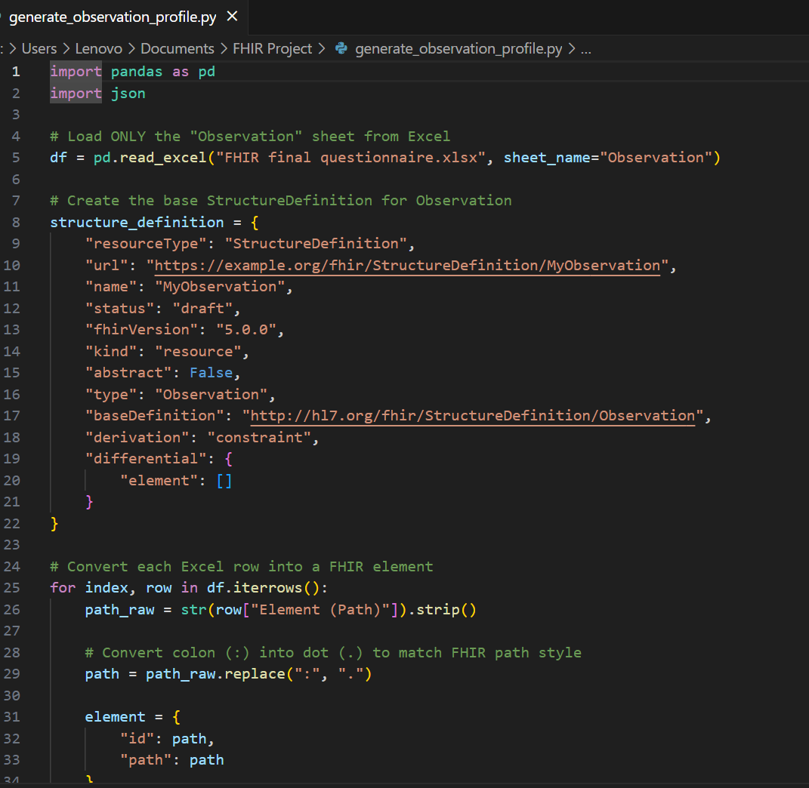

Photo 1: Python script for the automation of Observation Profile

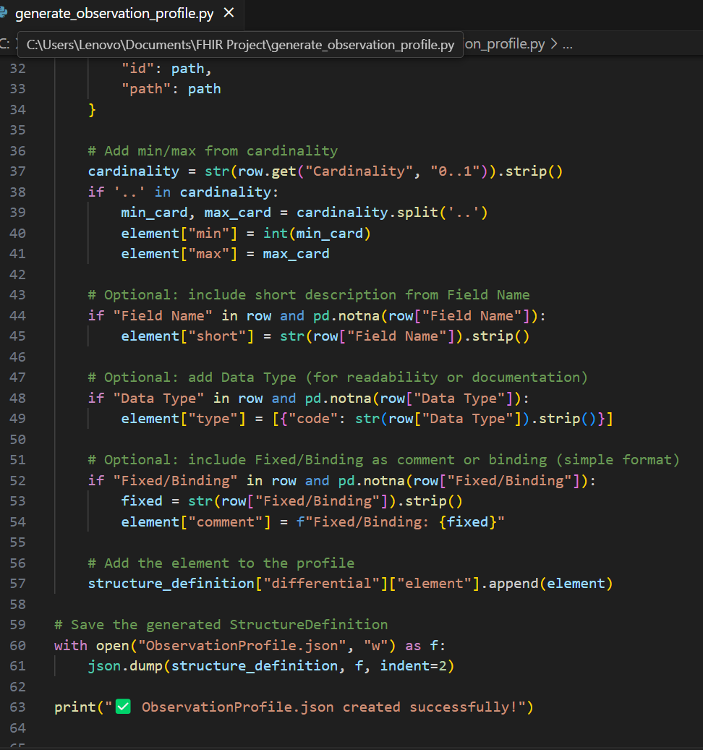

Photo 2: Python script for the automation of Observation Profile

## 4. Custom Profile Definition and Validation

The generated ObservationProfile.json defined custom constraints for hypertension-related observations, such as:

* Mandatory inclusion of systolic and diastolic blood pressure as Observation.component elements, with units fixed to mm[Hg]
* Optional inclusion of heart rate, symptoms (e.g., headache, chest pain), lifestyle factors, and lab results, each with appropriate data types and value bindings
* Use of standard terminologies and value sets for categorical fields (e.g., hypertension stage, BMI category, lifestyle)

All JSON resource files and profiles were validated against the HL7 FHIR specification using the [HAPI FHIR validator](https://hapi.fhir.org/baseR4/swagger-ui/), ensuring compliance and interoperability.

## 5. Documentation and Traceability

Throughout the methodology, the Excel mapping file served as a central reference, providing traceability from clinical requirements to digital implementation. Screenshots and directory listings were maintained to document the workflow and project structure.

# Results

The implementation phase translated the mapped questionnaire domains into a comprehensive set of FHIR-compliant JSON resource files. These digital artifacts form the backbone of the hypertension data model, ensuring interoperability, standardization, and readiness for integration into health information systems. The following sections provide an overview of the generated resource files, a detailed look at the custom Observation profile, and descriptions of the key codes and constraints applied.

All resource files (e.g., Patient, Observation, Practitioner, Procedure, MedicationAdministration, Encounter, CarePlan) were authored and edited using Visual Studio Code and validated for conformance using the HAPI FHIR Test/Demo server via the Swagger UI (HAPI FHIR Project, 2025). This ensures that each resource instance is syntactically and semantically compliant with the FHIR standard, supporting reliable integration into health information systems.

Among these, the custom Observation profile is central for capturing structured blood pressure and other hypertension related clinical observations. The photographs below show the ObservationProfile.json file in Visual Studio Code, which defines the required elements and constraints for hypertension data.

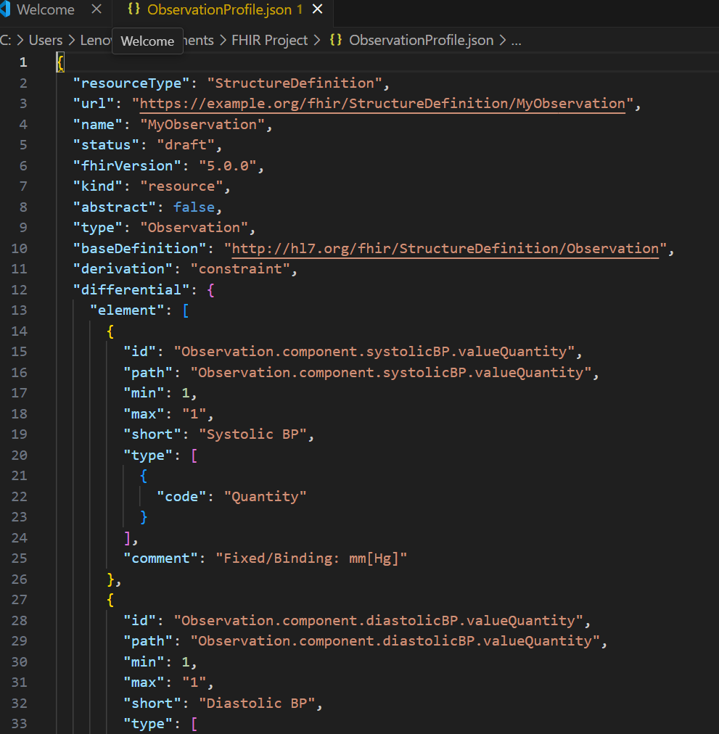

Photo 3: JSON of Observation Profile

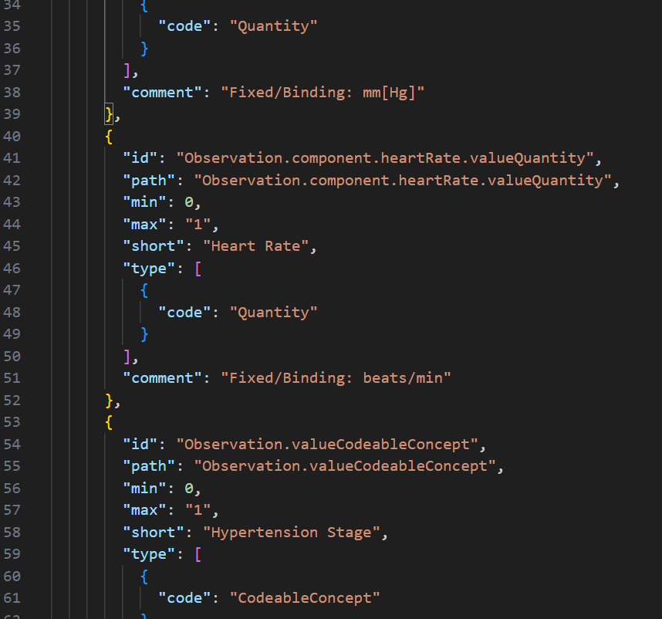

Photo 4: JSON of Observation Profile

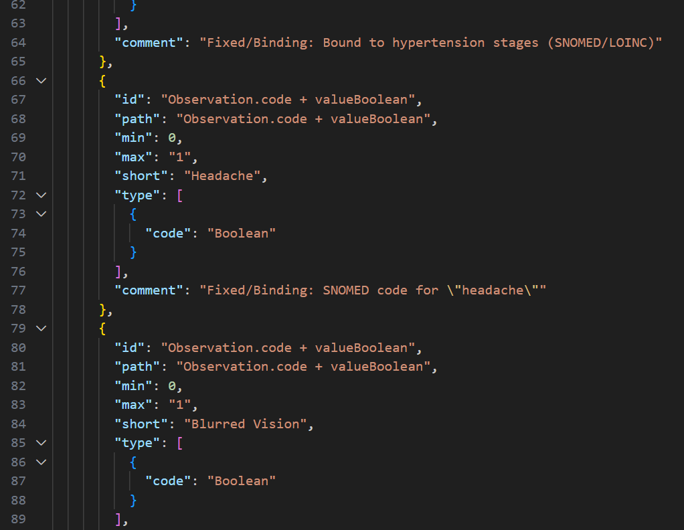

Photo 5: JSON for Observation Profile

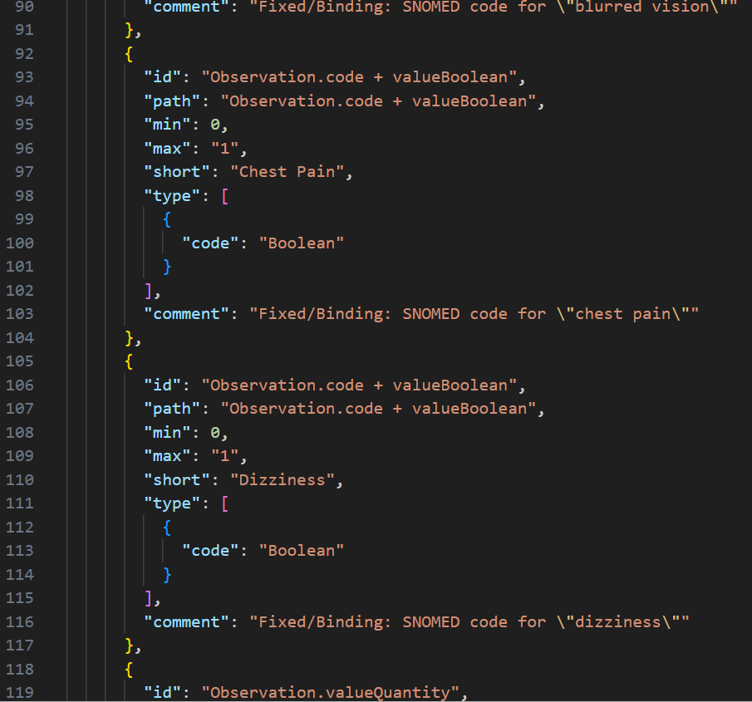

Photo 6: JSON of Observation Profile

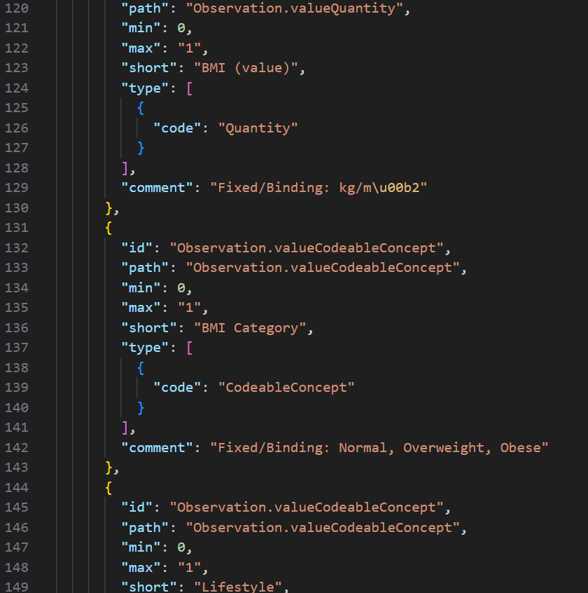

Photo 7:JSON of Observation Profile

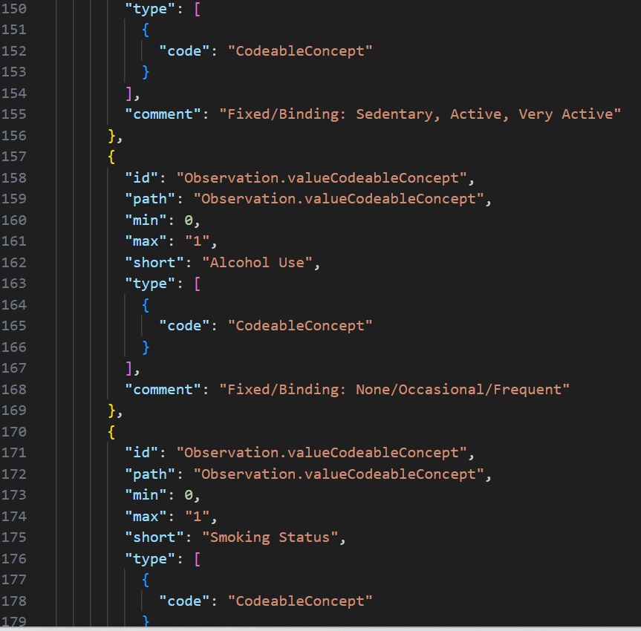

Photo 8: JSON for Observation Profile

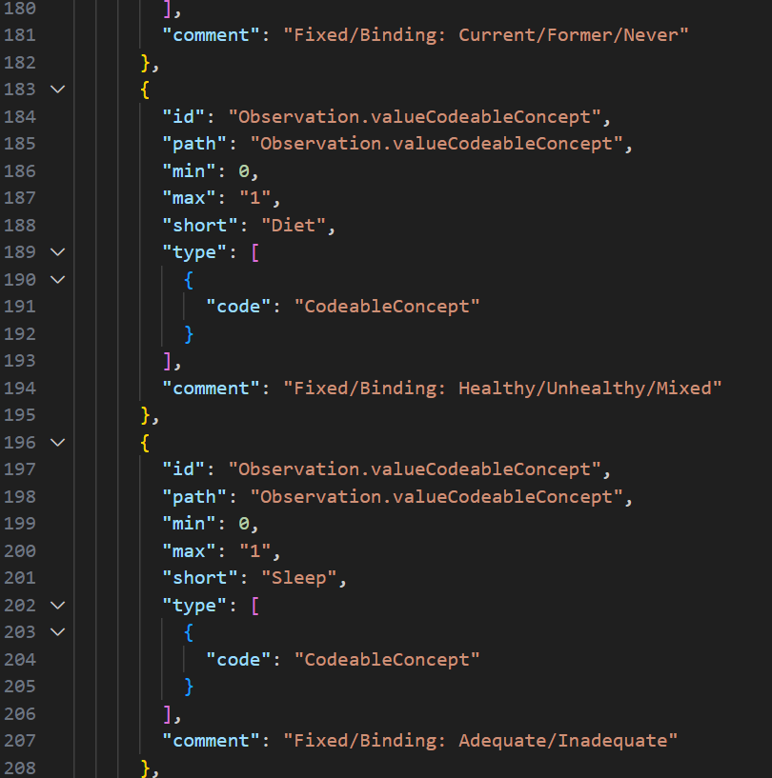

Photo 9: JSON for Observation Profile

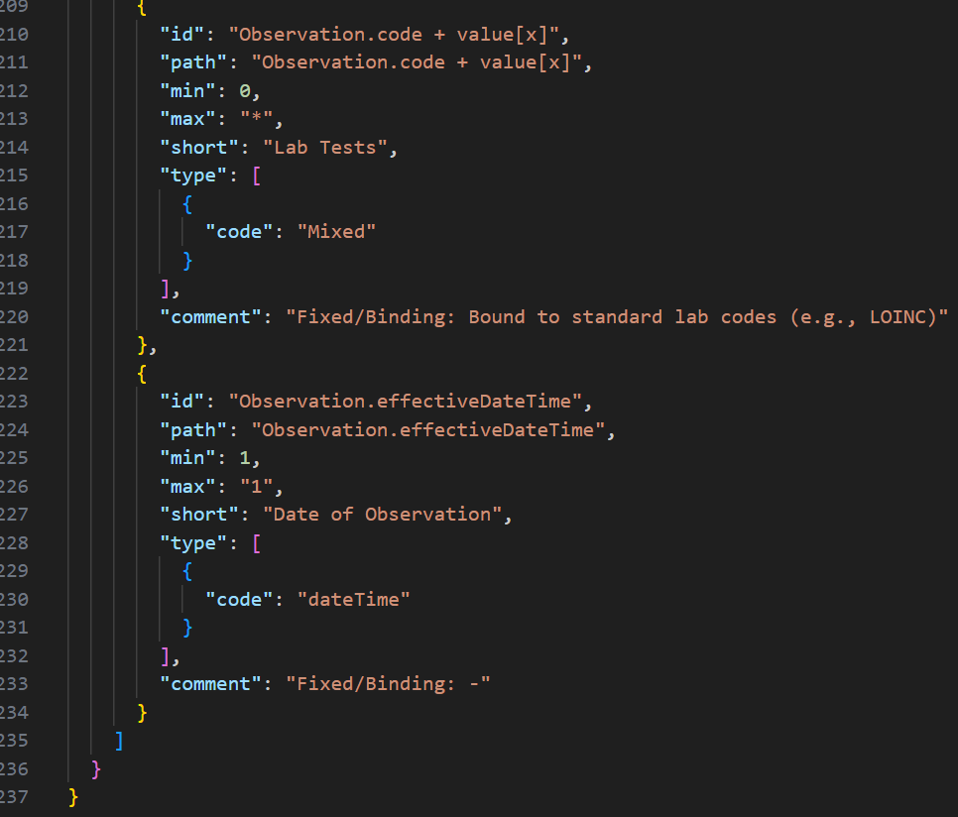

Photo 10: JSON for Observation Profile

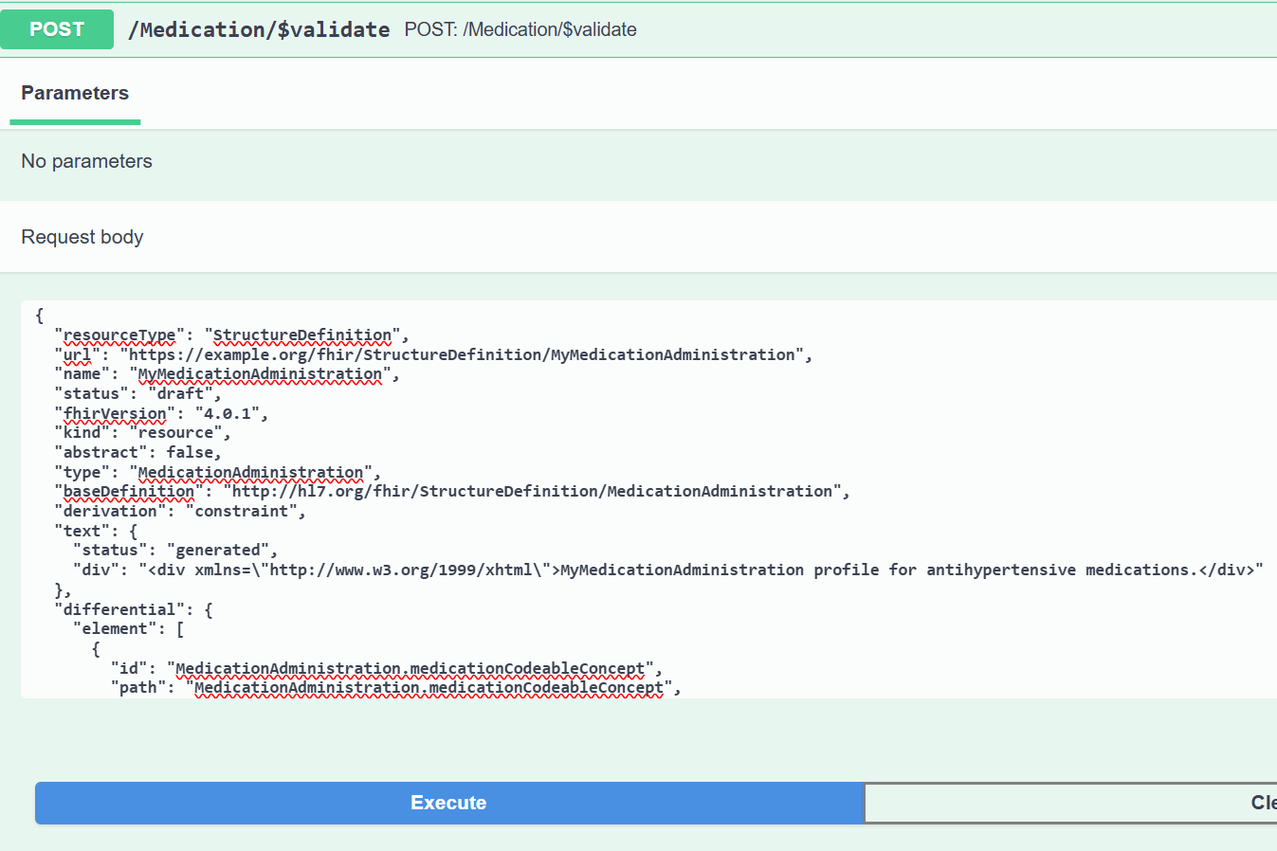

Photo 11: Validation of Structure Definition of MedicationAdministration in HAPI FHIR validator

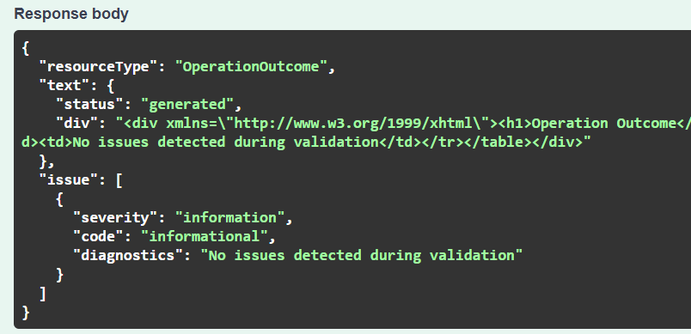

Photo 12: Validation results for Structure definition of Medication Administration

Each custom FHIR profile—such as those created for the Observation or Patient resources—begins with a standardized set of metadata fields that establish the profile’s unique identity, intended purpose, and its relationship to the underlying HL7 FHIR specification (HL7 International, 2024). In this project, the Observation resource has been specifically tailored to capture hypertension-related clinical data by defining these essential metadata fields at the outset of the JSON profile. The following is a description of the key fields utilized in this Observation profile JSON:

|  |  |  |
| --- | --- | --- |
| **Field** | **Description** | **Example value/Note** |
| ResourceType | Specifies the type of FHIR resource. For a profile definition, this is always "StructureDefinition". | "StructureDefinition" |
| url | The canonical URL that uniquely identifies this profile. | "https://example.org/fhir/StructureDefinition/MyObservation" |
| name | A human-readable name for this custom profile. | "MyObservation" |
| status | Publication status of the profile (e.g., "draft", "active"). | "draft" |
| fhirVersion | Indicates which version of the FHIR specification this profile uses. | "5.0.0" |
| kind | The kind of structure being defined. For resource profiles, this is "resource". | "resource" |
| abstract | Boolean indicating if the profile is abstract (cannot be used directly). Usually false for concrete profiles. | false |
| type | The base FHIR resource type being constrained. | "Observation" |
| baseDefinition | The canonical URL of the base FHIR resource being profiled. | "http://hl7.org/fhir/StructureDefinition/Observation" |
| derivation | Indicates this profile is a constraint on the base resource. | "constraint" |
| differential | Contains the elements where this profile differs from the base resource, i.e., our customizations. | See below |
| differential.element | An array listing each element that is constrained or defined in this profile. |  |
| id | Unique identifier for the element within the profile. | e.g., "Observation.component.systolicBP.valueQuantity" |
| path | The FHIR path to the element being constrained. | e.g., "Observation.component.systolicBP.valueQuantity" |
| min | Minimum cardinality (how many times this element must appear). | “1”: required  “0”: optional |
| max | Maximum cardinality (how many times this element can appear). | "1": the value appears once  “*”: the value can repeat |
| short | A short, human-readable description of the element. | e.g., "Systolic BP" |
| type | The FHIR data type for this element. | e.g., {"code": "Quantity"} |
| comment | Additional information or constraints on the element, such as fixed units. | e.g., "Fixed/Binding: mm[Hg]" |

In summary, the successful development and validation of FHIR-compliant JSON resource files—including the custom Observation profile—demonstrate the feasibility of translating structured clinical data requirements into interoperable digital artifacts. The use of standardized coding, clear cardinality, and domain-specific constraints ensures that each resource instance is both syntactically robust and semantically meaningful. These outputs provide a solid foundation for reliable data exchange and integration within health information systems, addressing the core objectives of this project. The results presented here lay the groundwork for further analysis, system integration, and real-world application, which will be explored in the subsequent sections.

# Discussion

The comprehensive development and validation of FHIR-compliant JSON resource files for hypertension management represent a major step toward digital health standardization and interoperability. This project extended well beyond a single resource, encompassing a suite of profiles—Patient, Observation, Practitioner, Procedure, MedicationAdministration, Encounter, and CarePlan—each mapped systematically from a structured questionnaire and aligned with the FHIR specification.

## Broader Significance and Impact

By translating multiple domains of hypertension care into discrete, standards-based digital artifacts, this work demonstrates how FHIR provides a robust foundation for interoperable health information systems. The Patient resource profile ensures accurate capture of demographic and identity data, while the Observation resource enables structured recording of clinical data such as blood pressure, heart rate Practitioner and Encounter resources link clinical events to healthcare providers and visits, supporting longitudinal patient tracking. Procedure and MedicationAdministration resources document interventions and therapies, and the CarePlan resource facilitates planning and coordination of ongoing care.

This holistic approach enables comprehensive, semantically rich data capture that can be reliably exchanged between systems, laying the groundwork for improved clinical decision support, population health analytics, and patient engagement.

## Challenges encountered

**1. Complex Data Mapping:**  
Mapping questionnaire fields to FHIR resources required careful analysis of both clinical intent and technical specification. For instance, the demographic profile involved aligning local data needs—such as district and state fields—with FHIR’s Patient.address structure, sometimes necessitating custom extensions or clear documentation of field usage.

**2. Cardinality and Constraint Decisions:**  
Determining the appropriate cardinality and required/optional status for fields was challenging, especially in domains such as contact information (telecom), where real-world variability is high. The team balanced strict data quality requirements with the need for flexibility in diverse clinical settings.

**3. Validation and Iteration:**  
Initial validation attempts using the HAPI FHIR Test/Demo server revealed subtle issues, including mismatches in data types and missing required fields. Iterative refinement, informed by validator feedback, was essential to achieving full syntactic and semantic conformance.

**4**. **Harmonizing Across Resources:**  
Ensuring consistency in coding systems, value sets, and field usage across multiple resources required coordinated documentation and frequent cross-checks. For example, gender codes and medication value sets had to be harmonized between Patient and MedicationAdministration profiles.

## Lessons learned

* **Iterative Development is Crucial:**  
  Early and frequent validation cycles allowed for the timely identification and correction of issues, preventing propagation of errors across resources.
* **Comprehensive Documentation Supports Consistency:**  
  Maintaining detailed mapping files and clear resource documentation facilitated communication within the team and streamlined troubleshooting.
* **Balance Between Specificity and Flexibility:**  
  Profiles must be specific enough to ensure data quality and interoperability but flexible enough to accommodate local workflows and evolving clinical needs.
* **Value of Modular Design:**  
  Treating each domain as a distinct resource allowed for modular development, testing, and future extensibility. This modularity is reflected in the organized project directory.

## Relevance to Nepal

Although HL7 FHIR is an international standard, its adoption in Nepal is still in early phases. This project contributes to the growing need for local capacity building and experimentation with global health interoperability frameworks. By applying FHIR in a structured questionnaire for hypertension management—a high-burden condition in Nepal—it demonstrates a practical use case for digitization in resource-constrained environments.

The approach taken in this project can be extended to other chronic disease registries, public health reporting systems, or mobile health applications. As Nepal begins to move toward health information exchanges and electronic health record systems, such FHIR-based prototypes can serve as foundational blueprints for larger-scale digital health initiatives.

# Conclusion

This project successfully developed and validated a FHIR-compliant digital questionnaire for hypertension management, transforming structured clinical inputs into standardized HL7 FHIR resource files. By implementing key FHIR resources—such as Patient, Observation, MedicationStatement, Procedure, Encounter, and CarePlan—in JSON format, the project demonstrated how clinical data can be made interoperable, reusable, and machine-readable. The use of custom FHIR profiles and standardized terminologies like LOINC, SNOMED CT, and UCUM ensured semantic interoperability, enabling accurate and meaningful data exchange across systems. Validation through tools like the HAPI FHIR Validator reinforced the technical quality and consistency of each resource.

Despite some challenges, including the complexity of FHIR’s structure and the lack of localized examples for the Nepali context, the project highlighted the practical value of adopting international health IT standards at a national or institutional level. It also provided an opportunity to deepen technical understanding of FHIR and the broader principles of interoperability in digital health.

In summary, this work serves as a foundational step toward the development of structured, standards-based health information systems in Nepal and similar settings, supporting better data quality, care coordination, and future scalability.

# References

Adler-Milstein, J., & Jha, A. K. (2017). HITECH Act drove large gains in hospital electronic health record adoption. *Health Affairs, 36*(8), 1416–1422. <https://doi.org/10.1377/hlthaff.2016.1651>

Bender, D., & Sartipi, K. (2013). HL7 FHIR: An Agile and RESTful approach to healthcare information exchange. *Proceedings of the 26th IEEE International Symposium on Computer-Based Medical Systems*, 326–331. <https://doi.org/10.1109/CBMS.2013.6627810>

Dolin, R. H., Alschuler, L., Beebe, C., Biron, P. V., Boyer, S., Essin, D., & Shabo, A. (2006). The HL7 Clinical Document Architecture. *Journal of the American Medical Informatics Association, 13*(1), 30–39. <https://doi.org/10.1197/jamia.M1887>

HAPI FHIR Project. (2025). HAPI FHIR Test/Demo Server R4 Swagger UI. <https://hapi.fhir.org/baseR4/swagger-ui/>

HL7 International. (2024). FHIR Release 5.0.0. <https://hl7.org/fhir/>

HL7 International. (2022). FHIR Release 5 – Overview. <https://hl7.org/FHIR/overview.html>

Mandl, K. D., Gottlieb, D., Ellis, A., & Mandel, J. C. (2020). The evolution of APIs and health information sharing. *JAMA, 324*(15), 1539–1540. <https://doi.org/10.1001/jama.2020.16221>

Mills, K. T., Stefanescu, A., & He, J. (2020). The global epidemiology of hypertension. *Nature Reviews Nephrology, 16*(4), 223–237. <https://doi.org/10.1038/s41581-019-0244-2>

Vreeman, D. J., McDonald, C. J., & Huff, S. M. (2016). LOINC: A universal catalogue of individual clinical observations and uniform representation of lab results. *Methods of Information in Medicine, 55*(4), 349–355. <https://doi.org/10.3414/ME15-01-0157>

World Health Organization. (2021). Hypertension. <https://www.who.int/news-room/fact-sheets/detail/hypertension>